Ali AlHabeeb

421109639

# part 1:Screenshot 2025-01-30 at 1.36.08 PM.png

# part 2:

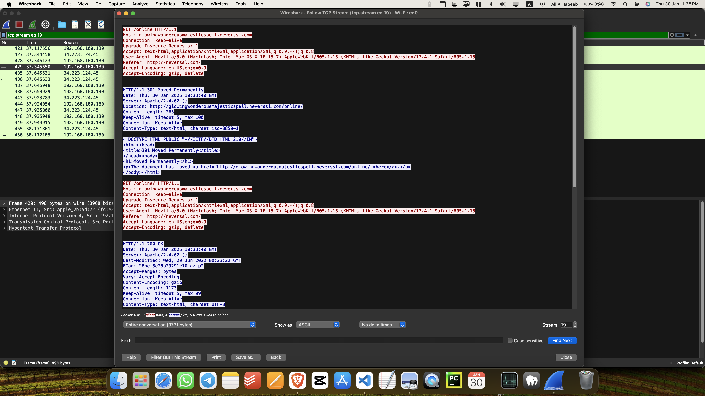you see here this is the tcp packets

this is the tcp handshake :



here is the data packets exchange and termination process :

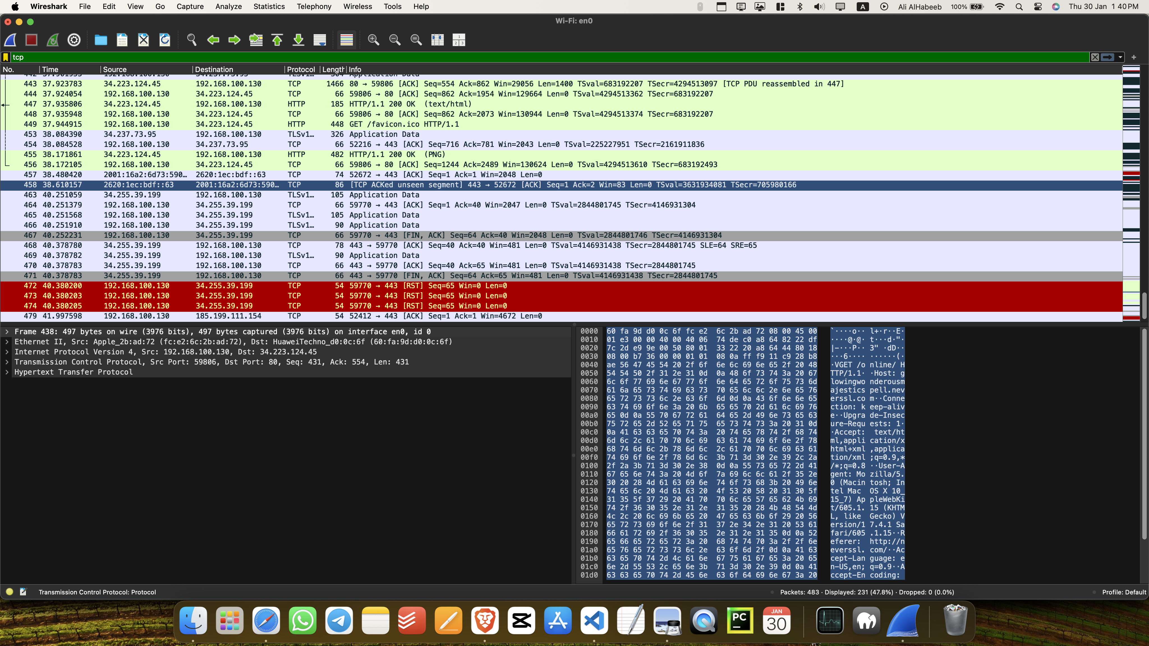Screenshot 2025-01-30 at 1.40.29 PM.png

# part 3:Screenshot 2025-01-30 at 1.43.21 PM.png

you see here the header file and the packet size for UDP is much smaller than TCP

# part 4 :

|  | TCP or UDP | Resons |
| --- | --- | --- |
| Reliability and Connection  Establishment | TCP | TCP is connection-oriented, using a three-way handshake (SYN, SYN-ACK, ACK) to establish a connection. It ensures reliability through acknowledgments and retransmissions of lost packets. |
| Data Integrity and Ordering | TCP | TCP guarantees both data integrity (via checksums) and ordered delivery (via sequence numbers). UDP provides optional checksums for integrity but does not ensure packet ordering. |

|  | TCP | UDP |
| --- | --- | --- |
| Use cases | Applications requiring reliable delivery: web browsing (HTTP), email (SMTP), file transfers (FTP). | Real-time applications: video streaming, VoIP, online gaming, live broadcasts (where speed is prioritized over reliability). |
| Performance | Slower due to connection setup, acknowledgments, and congestion control. Higher reliability but increased latency. | Faster with minimal overhead. Lower latency but no reliability guarantees, making it suitable for time-sensitive transmissions. |